**Hyperledger Fabric Installation Guide**

**This document will provide the overview and installation process of Hyperledger Fabric**

Hyperledger Fabric is an open source enterprise-grade permissioned distributed ledger technology (DLT) platform, designed for use in enterprise contexts, which was established under the Linux Foundation

This technology enables confidentiality through its channel architecture.

Fabric is comprised of the following components:

* A pluggable *ordering service*.
* A pluggable *membership service provider*.
* *peer-to-peer gossip service*.
* Smart contracts (“chaincode”) run within a container environment (e.g. Docker) for isolation.
* A pluggable endorsement and validation policy enforcement that can be independently configured per application.

Hyperledger Fabric can be configured in multiple ways to satisfy the diverse solution requirements.

Below are the Pre-requisite to get the infrastructure ready

* **Hyperledger fabric Installation version (v1.4)**
* Visual studio code with extension (for extension please follow the steps in the link <https://code.visualstudio.com/docs/remote/ssh-tutorial> )
* Please have a oracle VM installed with ubuntu 16.04
* To SSH into the machine please have install openssh-client

Once you are ready with the above set up lets ssh and Start with the installation process.

Post SSH we will have the visual studio code connected to the VM

**System requirements**

* **Update the machine**

sudo apt update

sudo apt -y upgrade

* **Installing Curl**

sudo apt install curl

* **Next we will install GIT**

sudo apt install git

* **Install Python**

sudo apt install -y python-minimal

**Install Docker and Docker compose**

**sudo apt install apt-transport-https ca-certificates gnupg-agent software-properties-common**

**curl -fsSL** ​**https://download.docker.com/linux/ubuntu/gpg**​ **| sudo apt-key add -**

**sudo add-apt-repository "deb [arch=amd64] https://download.docker.com/linux/ubuntu**​ **$(lsb_release -cs) stable"**

**sudo apt update**

**sudo apt -y install docker-ce**

**sudo usermod -aG docker <YourUserNameGoesHere>**

**sudo curl -L https://github.com/docker/compose/releases/download/1.18.0/docker-comp ose-`uname**​ **-s`-`uname -m` -o /usr/local/bin/docker-compos**​e

**sudo chmod +x /usr/local/bin/docker-compose**

**sudo reboot now.**

**Let’s change the Directory and move the desktop**

Once you are in the Desktop directory Use the following command to curl down the ​**fabric-samples**​ project folder, and Docker images

**curl -sSL** ​**http://bit.ly/2ysbOFE**​ **| bash -s 1.4.0**

once the download is complete you should see as below

Now let’s verify if everything is installed in a proper order

* docker-compose -v
* docker -v
* git -v

Check if you have all the docker images required downloaded locally

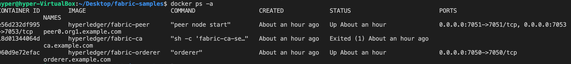

Coming soon!! This is a Part 1 of the document on Hyperledger fabric, we will update the advance concepts!!

For any queries please reach out to me : [resourcee.labb@gmail.com](mailto:resourcee.labb@gmail.com)